Progress Report of State-of-Health (SOH) Estimation of Lithium-Ion Batteries Using Two-Stage Autoencoder and BPNN

Baseline Evaluation and Root Cause Analysis of AE-BPNN Generalization for SOH Estimation

Update Summary: This report presents the progress of our research in Phase 2 (Scenario A). It directly addresses the recent feedback regarding data leakage prevention, interpolation methods, and the evaluation of the Autoencoder's reconstruction ability. The report provides quantitative evidence to establish the baseline performance and analyzes the limitations of the current AE-BPNN model when tested on unseen battery data.

Name: Padipat Aincham (林志龍) ID: M11452803
Date: 2026.09.02
Table of Contents

- Introduction and Current Progress
- Section 1: Data Integrity and Causal Preprocessing
- Section 2: Physical Validity in Data Interpolation
- Section 3: Empirical Initialization and Controlled Parameters
- Section 4: Root Cause Analysis on Unseen Domain
- Section 5: SOH Prediction and Ablation Results
- Section 6: Next Steps for the Upcoming Progress

Introduction and Current Progress
To provide a clear context for this update, it is important to review our overall research roadmap. As illustrated in Figure 1, the project is divided into four main phases. Previously, we completed Phase 1, which involved building a robust data pipeline, specifically enhancing the EIS data representation into a 16x16 format for model training.

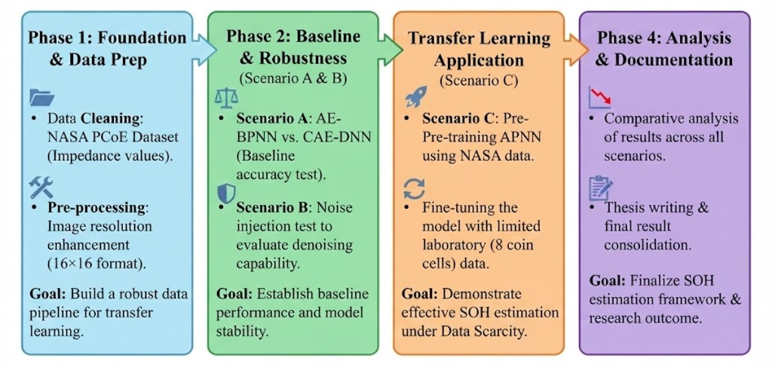
Figure 1: The overall research roadmap showing the transition from data preparation to transfer learning.

Currently, we are executing Phase 2, which focuses on establishing baseline performance and model stability. According to our experimental scenarios detailed in Figure 2, we are actively working on Scenario A: Baseline Evaluation. The primary goal of this scenario is to test the standard AE-BPNN architecture and establish its baseline accuracy for State-of-Health (SOH) estimation before we introduce any complex techniques like noise injection or transfer learning.
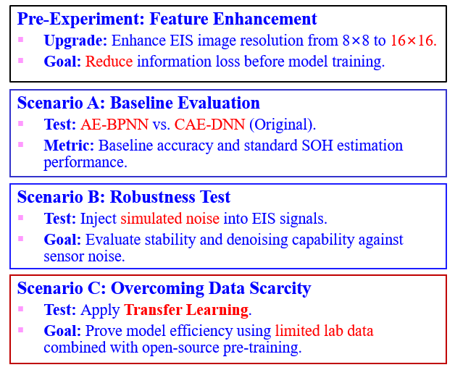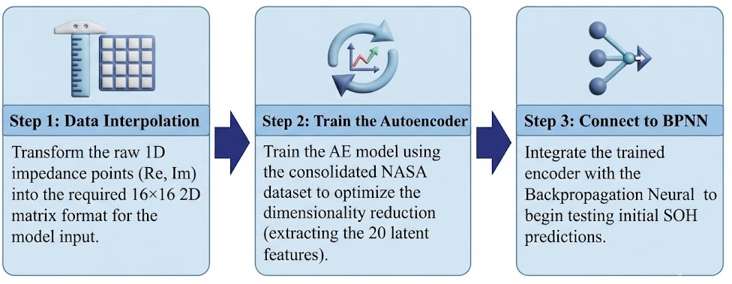
Figure 2: Detailed experimental scenarios, with current focus on Scenario A (Baseline Evaluation).
During the implementation of Scenario A, I carefully reviewed your recent feedback regarding the evaluation methodology. To ensure the research meets high academic standards, this report systematically addresses your concerns. I have conducted strict ablation studies to evaluate different data interpolation methods (Linear, Cubic Spline, and PCHIP) and analyzed the Autoencoder's reconstruction performance using quantitative metrics (RMSE, MAE, R-squared).
The following sections will present the empirical evidence collected during these tests. Instead of only showing the final SOH predictions, this report investigates the entire data pipeline to understand how each processing step affects the model. Notably, we observed significant generalization challenges when the AE-BPNN model was evaluated on unseen data (Battery B0018). Therefore, this report also includes a root cause analysis to explain this behavior using physical and statistical evidence
Section 1: Data Integrity and Causal Preprocessing
To prevent data leakage during model training, I used a strict Leave-One-Battery-Out (LOBO) split. The training set includes data from batteries B0005, B0006, and B0007. Battery B0018 is kept strictly as the unseen test set. This ensures the model does not see any test data during the training phase.
Next, I prepared the dataset by matching the EIS measurements with the Capacity measurements. The raw data comes from two files: NASA_Impedance_Data.csv and NASA_Capacity_Data.csv. Because the EIS and Capacity tests were not always recorded at the exact same cycle, I applied a "Causal Backward Mapping" method. This method only matches an EIS record with a past capacity record. It strictly prevents future data leakage.
To find the right cycle gap (tolerance) for matching, I tested different tolerance levels. The goal is to keep as much data as possible without matching cycles that are too far apart, which could cause semantic drift (the battery's health changes too much between cycles).

Quantitative Sensitivity Analysis of Mapping Tolerance
1. Strategy A: Exact Match Performance
Strategy | Matched Records | Data Loss
Exact Match | 0 / 887 (0.00%) | 887 records

2. Strategy C: Causal Backward Nearest Neighbor Sensitivity
Tolerance (Cycles) | Matched Records | Total Records | Retention Rate (%) | Data Loss
1 | 452 | 887 | 50.96% | 435
2 | 477 | 887 | 53.78% | 410
3 | 886 | 887 | 99.89% | 1
4 | 886 | 887 | 99.89% | 1
5 | 886 | 887 | 99.89% | 1
6 | 886 | 887 | 99.89% | 1
7 | 886 | 887 | 99.89% | 1
8 | 886 | 887 | 99.89% | 1
9 | 886 | 887 | 99.89% | 1
10 | 886 | 887 | 99.89% | 1
20 | 886 | 887 | 99.89% | 1
50 | 886 | 887 | 99.89% | 1
100 | 886 | 887 | 99.89% | 1
Table 1: Sensitivity Analysis of Mapping Tolerance (Causal Backward Matching)

As shown in Table 1, a tolerance of 3 cycles is the optimal balance. It achieves a 99.89% data retention rate (886 out of 887 records). Increasing the tolerance beyond 3 cycles does not recover any more data. Therefore, I set the mapping tolerance to 3 to maintain data accuracy and avoid large cycle gaps.

Section 2: Physical Validity in Data Interpolation
As requested, I compared Linear, Cubic Spline, and PCHIP interpolation methods to evaluate how they affect SOH prediction performance. I tested these methods using both Linear and Logarithmic frequency grids. The baseline AE-BPNN model was used for this test.

Frequency_Grid | Interpolation_Method | Train_RMSE | Train_R2 | Test_MAE | Test_RMSE | Test_R2
log_grid | cubic | 0.0449 | 0.9445 | 0.2021 | 0.2506 | -1.1235
linear_grid | cubic | 0.0457 | 0.9425 | 0.2105 | 0.2516 | -1.1419
log_grid | linear | 0.0464 | 0.9408 | 0.2149 | 0.2625 | -1.3314
log_grid | pchip | 0.0452 | 0.9437 | 0.2149 | 0.2636 | -1.3499
linear_grid | linear | 0.0465 | 0.9404 | 0.2179 | 0.2652 | -1.3788
linear_grid | pchip | 0.0446 | 0.9451 | 0.2184 | 0.2665 | -1.4031
Table 2: Interpolation Ablation Results on Unseen Data (Battery B0018)

Table 2 shows the prediction results on the unseen test set (B0018). All methods have a negative Test R-squared, which means the baseline model struggles with the new battery domain. Based only on the numbers, the Log-Grid with Cubic Spline provides the lowest Test RMSE (0.2505 Ah). The Log-Grid with PCHIP has a slightly higher error (0.2635 Ah).
However, I decided to reject the Cubic Spline method. The justification is based on the physical validity of the data, as shown in the figures below.

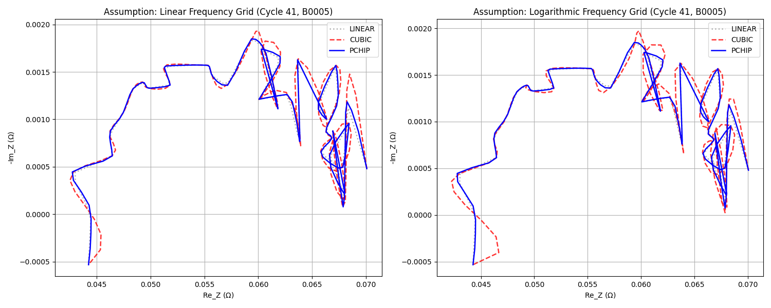
Figure 3: Comparison of interpolation methods on the Nyquist plot (Cycle 41, B0005).
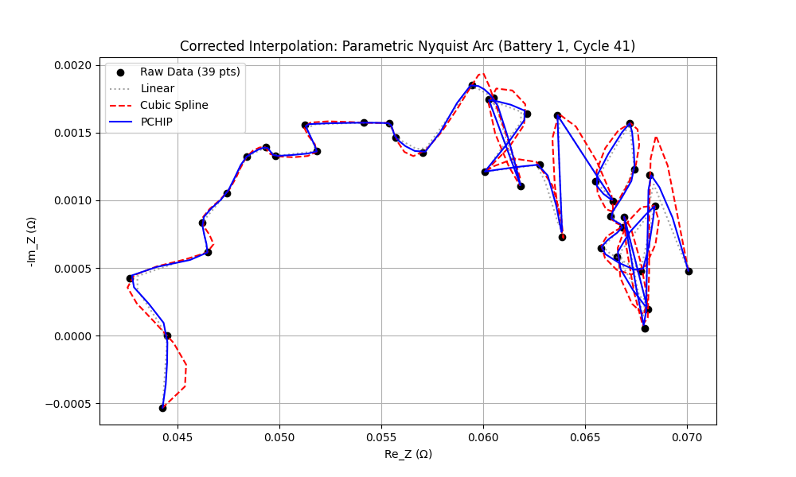
Figure 4: Detailed view of the interpolation overshoot effect on impedance data.

Figures 3 and 4 illustrate how each method connects the raw EIS data points. The red dashed line represents the Cubic Spline method. It creates severe overshoots and artificial curves that go beyond the actual raw data. In electrochemistry, battery impedance cannot suddenly spike in this manner; this behavior is physically incorrect.
On the other hand, the blue solid line represents the PCHIP method. It connects the points while strictly preserving the true shape (monotonicity) of the raw signal without any overshoot.

Therefore, even though Cubic Spline gives a slightly lower RMSE (by 0.013 Ah), it introduces physically invalid artifacts. I selected Log-Grid with PCHIP as the standard data preparation method for this research because it maintains both the low-frequency information and the physical reality of the battery impedance.

Section 3: Empirical Initialization and Controlled Parameters
To ensure the experiment is reliable, every design choice must be supported by quantitative evidence. I did not select the model architecture and hyperparameters by guessing. I established them through data analysis and empirical testing.
First, I determined the bottleneck size for the Autoencoder. To prevent data leakage, I ran a Principal Component Analysis (PCA) strictly on the training set.

Target Variance | Exact Variance Captured | Optimal Bottleneck Size
80.0% | 80.4358% | 1
85.0% | 87.0844% | 3
90.0% | 90.5512% | 7
95.0% | 95.0617% | 17
99.0% | 99.0551% | 37
99.9% | 99.9090% | 67
Table 3: PCA Cumulative Explained Variance (Fitted on Training Data)

Table 3 shows that 17 latent dimensions can capture 95.06% of the dataset's total variance. Therefore, I locked the Autoencoder bottleneck size at 17. This provides a strong statistical foundation for the model.
Next, I needed to find the best learning rate (LR) and batch size. I performed a grid search and evaluated the models on the validation set (Battery B0007).

Batch_Size | AE_LR | BPNN_LR | Val_RMSE | Test_RMSE | Test_R2
16.0000 | 0.0010 | 0.0010 | 0.0987 | 0.2738 | -1.5347
16.0000 | 0.0005 | 0.0010 | 0.1080 | 0.3103 | -2.2567
32.0000 | 0.0010 | 0.0010 | 0.1083 | 0.3123 | -2.2979
32.0000 | 0.0005 | 0.0010 | 0.1102 | 0.3125 | -2.3022
32.0000 | 0.0005 | 0.0050 | 0.1133 | 0.2749 | -1.5560
32.0000 | 0.0010 | 0.0050 | 0.1288 | 0.3037 | -2.1204
16.0000 | 0.0010 | 0.0050 | 0.1459 | 0.3180 | -2.4207
16.0000 | 0.0005 | 0.0050 | 0.1482 | 0.2934 | -1.9120
Table 4: Hyperparameter Grid Search Results (Validation Set B0007)

Based on the results in Table 4, the combination of Batch Size = 16 and Learning Rate = 0.001 produced the lowest validation error without overfitting. I selected these values as the controlled parameters.
Finally, I analyzed the training convergence to determine the number of epochs.
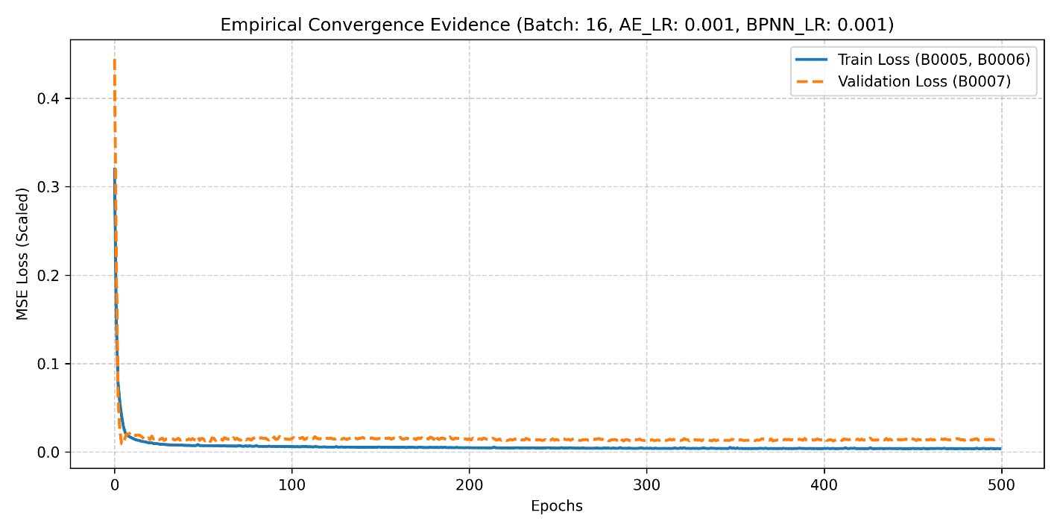Figure 5: Empirical Convergence Evidence (Batch: 16, LR: 0.001).
Figure 5 shows the learning curve of the baseline model. The training loss (solid blue line) and validation loss (dashed orange line) drop quickly and become flat around 300 epochs. This asymptotic convergence proves that the model has learned without overfitting. Therefore, I fixed the training process at 300 epochs for all following ablation studies.

Section 4: Root Cause Analysis on Unseen Domain
Following your feedback, I evaluated the Autoencoder (AE) to see if it can reconstruct unseen battery data. I also checked the correlation of the latent space to understand if the AE extracts meaningful features.
First, I analyzed the AE reconstruction error using physical units (Ohms).

Dataset | Mean_RMSE (Ohms) | Std_RMSE
Train (B0005, B0006) | 0.000728 | 0.000186
Validation (B0007) | 0.001148 | 0.000576
Unseen Test (B0018) | 0.001060 | 0.000241
Table 5: Autoencoder Reconstruction Performance (Physical Units: Ohms)

Table 5 shows the Mean RMSE for the Train, Validation, and Unseen Test sets. The Mean RMSE for the unseen test set (B0018) is very low (around 0.001 Ohms). At first glance, this number suggests that the AE performs good. However, because impedance values are naturally very small (milliohms), looking only at the RMSE number is misleading. We must visually inspect the physical shape of the data.
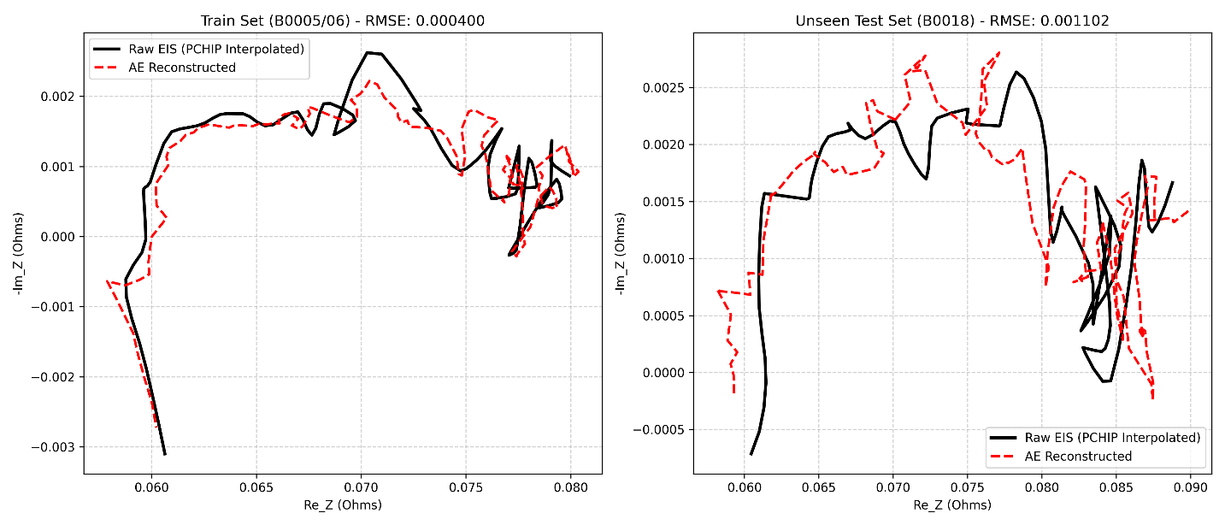
Figure 6: Comparison of Raw EIS and AE Reconstructed EIS on Train and Unseen Test Sets.
Figure 6 reveals the true problem. On the left (Train Set), the AE reconstructs the general shape of the Nyquist plot. But on the right (Unseen Test Set B0018), the AE fails. The reconstructed signal (red dashed line) shows severe distortion and a large phase shift compared to the raw signal (solid black line). This is empirical evidence that the AE is overfitting to the training domain. It cannot understand the EIS structure of a new battery.
Next, I analyzed the latent space (the 17 bottleneck nodes) to find out why the downstream SOH prediction fails. I calculated the Pearson and Spearman correlation between each latent node and the battery capacity.

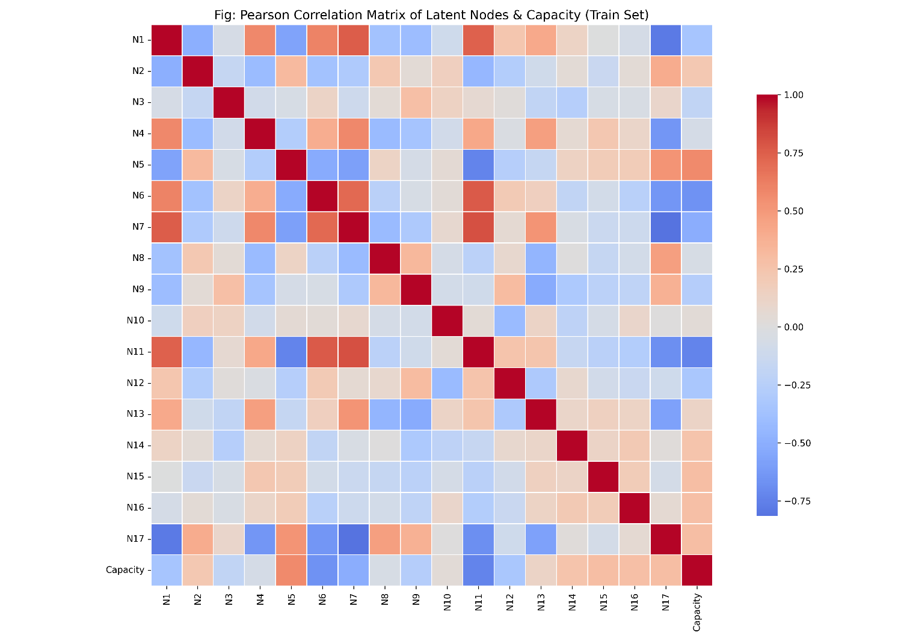
Figure 7: Pearson Correlation Matrix of Latent Nodes and Capacity (Train Set).

Figure 7 displays the heatmap of the latent space during training. It shows that only a few nodes have a strong correlation (dark red or dark blue) with the capacity. Many nodes have weak correlations, meaning they might just capture noise.
To understand the problem deeper, I compared the correlation values between the Train and Test sets.
Latent_Node | Train_Pearson_R | Train_Spearman_R | Test_Pearson_R | Test_Spearman_R
Node_1 | -0.3416 | -0.3495 | -0.4749 | -0.4723
Node_2 | 0.2219 | 0.1898 | 0.0953 | -0.0189
Node_3 | -0.1947 | -0.1948 | -0.1563 | -0.2345
Node_4 | -0.0699 | -0.0617 | 0.2472 | 0.3060
Node_5 | 0.5726 | 0.5698 | 0.5221 | 0.5105
Node_6 | -0.6587 | -0.6623 | 0.1680 | 0.1944
Node_7 | -0.5154 | -0.5101 | 0.0152 | -0.0745
Node_8 | -0.0539 | -0.0309 | 0.0546 | -0.0216
Node_9 | -0.2652 | -0.2601 | -0.3701 | -0.3878
Node_10 | 0.0316 | 0.0488 | 0.0556 | 0.0777
Node_11 | -0.7346 | -0.7284 | -0.2574 | -0.2807
Node_12 | -0.3260 | -0.2987 | -0.1063 | -0.0701
Node_13 | 0.1215 | 0.1007 | 0.2032 | 0.1742
Node_14 | 0.2505 | 0.2551 | 0.0456 | 0.0090
Node_15 | 0.2959 | 0.2921 | -0.0362 | 0.0026
Node_16 | 0.2879 | 0.2663 | -0.0273 | -0.0427
Node_17 | 0.2959 | 0.3037 | -0.3852 | -0.4213
Table 6: Top Latent Nodes Correlated with SOH (Train vs. Unseen Test)

Table 6 exposes the root cause of the model's failure. It shows a severe "Correlation Flip." For example:
- Node 11: During training, it has a strong negative correlation (-0.73) with capacity. But during testing on B0018, this correlation drops heavily to -0.25. The rule it learned is no longer strong.
- Node 6: This is the worst case. During training, it has a negative correlation (-0.65). However, during testing, the correlation flips to a positive direction (+0.16).

Conclusion: These findings prove that the failure is not caused by the downstream BPNN. The root cause is the upstream Autoencoder. The AE extracts features that change their meaning when applied to a new battery (Correlation Flip). When the BPNN receives these reversed features, it becomes blind and cannot predict the SOH correctly.

Section 5: SOH Prediction and Ablation Results
To test the downstream prediction performance, I conducted an ablation study. I tested 108 model configurations. I used the bottleneck sizes from the PCA analysis (1, 3, 7, 17, 37, and 67) and applied different L2 regularization values.

Bottleneck | Loss_Function | L2_  Regularization | Train_RMSE | Train_MAE | Train_R2 | Test_RMSE |  | Test_MAE | Test_R2 | Generalization  _Gap_RMSE
1 | MSE | 0.0000 | 0.1175 | 0.0846 | 0.6197 | 0.1752 |  | 0.1401 | -0.0387 | 0.0578
1 | MSE | 0.0000 | 0.1173 | 0.0846 | 0.6208 | 0.1744 |  | 0.1395 | -0.0290 | 0.0571
1 | MSE | 0.0001 | 0.1182 | 0.0854 | 0.6147 | 0.1806 |  | 0.1452 | -0.1031 | 0.0624
1 | MSE | 0.0010 | 0.1225 | 0.0864 | 0.5861 | 0.1900 |  | 0.1526 | -0.2215 | 0.0675
1 | MSE | 0.0100 | 0.1326 | 0.0969 | 0.5154 | 0.1999 |  | 0.1570 | -0.3519 | 0.0673
1 | MSE | 0.1000 | 0.1915 | 0.1598 | -0.0106 | 0.1789 |  | 0.1562 | -0.0823 | -0.0126
1 | MAE | 0.0000 | 0.1283 | 0.0800 | 0.5460 | 0.2138 |  | 0.1750 | -0.5454 | 0.0854
1 | MAE | 0.0000 | 0.1283 | 0.0801 | 0.5460 | 0.2137 |  | 0.1753 | -0.5441 | 0.0853
1 | MAE | 0.0001 | 0.1279 | 0.0800 | 0.5493 | 0.2131 |  | 0.1738 | -0.5367 | 0.0853
1 | MAE | 0.0010 | 0.1273 | 0.0805 | 0.5533 | 0.2130 |  | 0.1711 | -0.5346 | 0.0857
1 | MAE | 0.0100 | 0.1332 | 0.0861 | 0.5113 | 0.2264 |  | 0.1726 | -0.7334 | 0.0932
1 | MAE | 0.1000 | 0.1484 | 0.1164 | 0.3928 | 0.1916 |  | 0.1571 | -0.2412 | 0.0431
1 | Huber | 0.0000 | 0.1175 | 0.0846 | 0.6197 | 0.1752 |  | 0.1401 | -0.0387 | 0.0578
1 | Huber | 0.0000 | 0.1175 | 0.0846 | 0.6194 | 0.1784 |  | 0.1430 | -0.0760 | 0.0608
1 | Huber | 0.0001 | 0.1189 | 0.0859 | 0.6106 | 0.1810 |  | 0.1460 | -0.1082 | 0.0622
1 | Huber | 0.0010 | 0.1270 | 0.0897 | 0.5556 | 0.1987 |  | 0.1556 | -0.3355 | 0.0717
1 | Huber | 0.0100 | 0.1372 | 0.1040 | 0.4813 | 0.1935 |  | 0.1558 | -0.2659 | 0.0563
1 | Huber | 0.1000 | 0.1940 | 0.1600 | -0.0374 | 0.1844 |  | 0.1589 | -0.1500 | -0.0096
3 | MSE | 0.0000 | 0.0546 | 0.0404 | 0.9180 | 0.2661 |  | 0.2145 | -1.3958 | 0.2116
3 | MSE | 0.0000 | 0.0528 | 0.0391 | 0.9230 | 0.2663 |  | 0.2163 | -1.3981 | 0.2134
3 | MSE | 0.0001 | 0.0575 | 0.0431 | 0.9088 | 0.2516 |  | 0.2013 | -1.1405 | 0.1940
3 | MSE | 0.0010 | 0.0629 | 0.0478 | 0.8910 | 0.2492 |  | 0.1968 | -1.1011 | 0.1864
3 | MSE | 0.0100 | 0.1072 | 0.0813 | 0.6831 | 0.2525 |  | 0.1967 | -1.1569 | 0.1453
3 | MSE | 0.1000 | 0.1914 | 0.1598 | -0.0096 | 0.1786 |  | 0.1561 | -0.0791 | -0.0128
3 | MAE | 0.0000 | 0.0618 | 0.0433 | 0.8947 | 0.2374 |  | 0.1908 | -0.9069 | 0.1756
3 | MAE | 0.0000 | 0.0569 | 0.0392 | 0.9107 | 0.2494 |  | 0.1972 | -1.1041 | 0.1925
3 | MAE | 0.0001 | 0.0600 | 0.0425 | 0.9007 | 0.2415 |  | 0.1904 | -0.9733 | 0.1815
3 | MAE | 0.0010 | 0.0606 | 0.0429 | 0.8988 | 0.2439 |  | 0.1943 | -1.0119 | 0.1833
3 | MAE | 0.0100 | 0.0730 | 0.0530 | 0.8530 | 0.2372 |  | 0.1847 | -0.9036 | 0.1642
3 | MAE | 0.1000 | 0.1938 | 0.1599 | -0.0355 | 0.1841 |  | 0.1587 | -0.1458 | -0.0098
3 | Huber | 0.0000 | 0.0545 | 0.0404 | 0.9181 | 0.2662 |  | 0.2148 | -1.3972 | 0.2117
3 | Huber | 0.0000 | 0.0557 | 0.0415 | 0.9146 | 0.2557 |  | 0.2027 | -1.2108 | 0.2000
3 | Huber | 0.0001 | 0.0564 | 0.0415 | 0.9125 | 0.2644 |  | 0.2157 | -1.3641 | 0.2080
3 | Huber | 0.0010 | 0.0673 | 0.0514 | 0.8751 | 0.2555 |  | 0.2016 | -1.2074 | 0.1881
3 | Huber | 0.0100 | 0.1179 | 0.0910 | 0.6169 | 0.2209 |  | 0.1708 | -0.6502 | 0.1030
3 | Huber | 0.1000 | 0.1938 | 0.1599 | -0.0356 | 0.1841 |  | 0.1587 | -0.1460 | -0.0098
7 | MSE | 0.0000 | 0.0493 | 0.0363 | 0.9331 | 0.2585 |  | 0.2098 | -1.2603 | 0.2093
7 | MSE | 0.0000 | 0.0498 | 0.0373 | 0.9316 | 0.2764 |  | 0.2269 | -1.5837 | 0.2266
7 | MSE | 0.0001 | 0.0500 | 0.0372 | 0.9310 | 0.2656 |  | 0.2161 | -1.3856 | 0.2155
7 | MSE | 0.0010 | 0.0573 | 0.0427 | 0.9095 | 0.2485 |  | 0.1974 | -1.0886 | 0.1912
7 | MSE | 0.0100 | 0.0981 | 0.0745 | 0.7348 | 0.2419 |  | 0.1850 | -0.9784 | 0.1438
7 | MSE | 0.1000 | 0.1912 | 0.1599 | -0.0082 | 0.1782 |  | 0.1560 | -0.0746 | -0.0130
7 | MAE | 0.0000 | 0.0530 | 0.0362 | 0.9227 | 0.2681 |  | 0.2287 | -1.4312 | 0.2151
7 | MAE | 0.0000 | 0.0531 | 0.0370 | 0.9222 | 0.2655 |  | 0.2207 | -1.3843 | 0.2124
7 | MAE | 0.0001 | 0.0522 | 0.0353 | 0.9250 | 0.2704 |  | 0.2280 | -1.4728 | 0.2182
7 | MAE | 0.0010 | 0.0542 | 0.0371 | 0.9189 | 0.2724 |  | 0.2261 | -1.5098 | 0.2182
7 | MAE | 0.0100 | 0.0682 | 0.0486 | 0.8718 | 0.2250 |  | 0.1761 | -0.7118 | 0.1568
7 | MAE | 0.1000 | 0.1533 | 0.1202 | 0.3526 | 0.1870 |  | 0.1543 | -0.1826 | 0.0337
7 | Huber | 0.0000 | 0.0488 | 0.0360 | 0.9345 | 0.2593 |  | 0.2124 | -1.2746 | 0.2106
7 | Huber | 0.0000 | 0.0495 | 0.0368 | 0.9326 | 0.2701 |  | 0.2228 | -1.4673 | 0.2206
7 | Huber | 0.0001 | 0.0506 | 0.0371 | 0.9293 | 0.2737 |  | 0.2281 | -1.5344 | 0.2231
7 | Huber | 0.0010 | 0.0645 | 0.0486 | 0.8854 | 0.2419 |  | 0.1891 | -0.9789 | 0.1774
7 | Huber | 0.0100 | 0.1125 | 0.0857 | 0.6512 | 0.2136 |  | 0.1650 | -0.5428 | 0.1011
7 | Huber | 0.1000 | 0.1936 | 0.1599 | -0.0330 | 0.1836 |  | 0.1585 | -0.1401 | -0.0100
17 | MSE | 0.0000 | 0.0452 | 0.0349 | 0.9437 | 0.2636 |  | 0.2149 | -1.3499 | 0.2184
17 | MSE | 0.0000 | 0.0444 | 0.0344 | 0.9458 | 0.2693 |  | 0.2212 | -1.4522 | 0.2249
17 | MSE | 0.0001 | 0.0438 | 0.0335 | 0.9471 | 0.2642 |  | 0.2141 | -1.3609 | 0.2204
17 | MSE | 0.0010 | 0.0533 | 0.0405 | 0.9216 | 0.2461 |  | 0.1931 | -1.0491 | 0.1928
17 | MSE | 0.0100 | 0.0903 | 0.0682 | 0.7754 | 0.2433 |  | 0.1868 | -1.0015 | 0.1530
17 | MSE | 0.1000 | 0.1913 | 0.1599 | -0.0088 | 0.1784 |  | 0.1560 | -0.0767 | -0.0129
17 | MAE | 0.0000 | 0.0488 | 0.0338 | 0.9344 | 0.2545 |  | 0.2029 | -1.1912 | 0.2058
17 | MAE | 0.0000 | 0.0493 | 0.0342 | 0.9330 | 0.2591 |  | 0.2064 | -1.2712 | 0.2098
17 | MAE | 0.0001 | 0.0481 | 0.0342 | 0.9361 | 0.2586 |  | 0.2114 | -1.2624 | 0.2105
17 | MAE | 0.0010 | 0.0480 | 0.0331 | 0.9364 | 0.2568 |  | 0.2077 | -1.2298 | 0.2087
17 | MAE | 0.0100 | 0.0635 | 0.0457 | 0.8890 | 0.2254 |  | 0.1716 | -0.7189 | 0.1620
17 | MAE | 0.1000 | 0.1161 | 0.0850 | 0.6284 | 0.1964 |  | 0.1541 | -0.3046 | 0.0803
17 | Huber | 0.0000 | 0.0448 | 0.0349 | 0.9447 | 0.2616 |  | 0.2094 | -1.3156 | 0.2168
17 | Huber | 0.0000 | 0.0455 | 0.0354 | 0.9429 | 0.2650 |  | 0.2182 | -1.3759 | 0.2195
17 | Huber | 0.0001 | 0.0454 | 0.0346 | 0.9432 | 0.2664 |  | 0.2162 | -1.4002 | 0.2210
17 | Huber | 0.0010 | 0.0587 | 0.0447 | 0.9051 | 0.2401 |  | 0.1847 | -0.9502 | 0.1814
17 | Huber | 0.0100 | 0.1033 | 0.0770 | 0.7057 | 0.2166 |  | 0.1646 | -0.5865 | 0.1133
17 | Huber | 0.1000 | 0.1937 | 0.1599 | -0.0341 | 0.1838 |  | 0.1586 | -0.1425 | -0.0099
37 | MSE | 0.0000 | 0.0321 | 0.0246 | 0.9716 | 0.2575 |  | 0.2089 | -1.2432 | 0.2254
37 | MSE | 0.0000 | 0.0313 | 0.0240 | 0.9729 | 0.2650 |  | 0.2120 | -1.3756 | 0.2337
37 | MSE | 0.0001 | 0.0330 | 0.0258 | 0.9699 | 0.2587 |  | 0.2045 | -1.2632 | 0.2257
37 | MSE | 0.0010 | 0.0465 | 0.0348 | 0.9404 | 0.2538 |  | 0.1988 | -1.1787 | 0.2073
37 | MSE | 0.0100 | 0.0833 | 0.0616 | 0.8088 | 0.2465 |  | 0.1895 | -1.0551 | 0.1632
37 | MSE | 0.1000 | 0.1912 | 0.1599 | -0.0082 | 0.1782 |  | 0.1560 | -0.0746 | -0.0130
37 | MAE | 0.0000 | 0.0438 | 0.0264 | 0.9471 | 0.2839 |  | 0.2299 | -1.7252 | 0.2401
37 | MAE | 0.0000 | 0.0419 | 0.0256 | 0.9517 | 0.2809 |  | 0.2355 | -1.6692 | 0.2391
37 | MAE | 0.0001 | 0.0435 | 0.0282 | 0.9479 | 0.2773 |  | 0.2245 | -1.6018 | 0.2339
37 | MAE | 0.0010 | 0.0438 | 0.0282 | 0.9472 | 0.2984 |  | 0.2448 | -2.0110 | 0.2546
37 | MAE | 0.0100 | 0.0589 | 0.0410 | 0.9044 | 0.2451 |  | 0.1878 | -1.0320 | 0.1862
37 | MAE | 0.1000 | 0.1143 | 0.0822 | 0.6401 | 0.2023 |  | 0.1569 | -0.3848 | 0.0881
37 | Huber | 0.0000 | 0.0321 | 0.0246 | 0.9716 | 0.2575 |  | 0.2089 | -1.2432 | 0.2254
37 | Huber | 0.0000 | 0.0319 | 0.0241 | 0.9720 | 0.2657 |  | 0.2142 | -1.3881 | 0.2339
37 | Huber | 0.0001 | 0.0364 | 0.0279 | 0.9635 | 0.2501 |  | 0.1995 | -1.1156 | 0.2137
37 | Huber | 0.0010 | 0.0564 | 0.0414 | 0.9124 | 0.2579 |  | 0.2031 | -1.2504 | 0.2016
37 | Huber | 0.0100 | 0.1001 | 0.0736 | 0.7239 | 0.2221 |  | 0.1680 | -0.6688 | 0.1220
37 | Huber | 0.1000 | 0.1936 | 0.1599 | -0.0329 | 0.1836 |  | 0.1585 | -0.1398 | -0.0100
67 | MSE | 0.0000 | 0.0351 | 0.0274 | 0.9661 | 0.2603 |  | 0.2102 | -1.2921 | 0.2253
67 | MSE | 0.0000 | 0.0347 | 0.0264 | 0.9668 | 0.2656 |  | 0.2144 | -1.3859 | 0.2309
67 | MSE | 0.0001 | 0.0434 | 0.0341 | 0.9480 | 0.2794 |  | 0.2289 | -1.6403 | 0.2360
67 | MSE | 0.0010 | 0.0489 | 0.0379 | 0.9342 | 0.2606 |  | 0.2097 | -1.2964 | 0.2117
67 | MSE | 0.0100 | 0.0870 | 0.0672 | 0.7913 | 0.2655 |  | 0.2104 | -1.3838 | 0.1785
67 | MSE | 0.1000 | 0.1913 | 0.1599 | -0.0085 | 0.1783 |  | 0.1560 | -0.0757 | -0.0129
67 | MAE | 0.0000 | 0.0454 | 0.0303 | 0.9431 | 0.2646 |  | 0.2124 | -1.3674 | 0.2191
67 | MAE | 0.0000 | 0.0398 | 0.0257 | 0.9564 | 0.2608 |  | 0.2122 | -1.3002 | 0.2210
67 | MAE | 0.0001 | 0.0431 | 0.0285 | 0.9489 | 0.2654 |  | 0.2215 | -1.3827 | 0.2224
67 | MAE | 0.0010 | 0.0428 | 0.0282 | 0.9495 | 0.2833 |  | 0.2373 | -1.7139 | 0.2404
67 | MAE | 0.0100 | 0.0584 | 0.0422 | 0.9060 | 0.2503 |  | 0.1993 | -1.1183 | 0.1919
67 | MAE | 0.1000 | 0.1203 | 0.0870 | 0.6012 | 0.1904 |  | 0.1531 | -0.2259 | 0.0701
67 | Huber | 0.0000 | 0.0353 | 0.0277 | 0.9656 | 0.2655 |  | 0.2129 | -1.3839 | 0.2302
67 | Huber | 0.0000 | 0.0352 | 0.0270 | 0.9658 | 0.2584 |  | 0.2078 | -1.2591 | 0.2232
67 | Huber | 0.0001 | 0.0483 | 0.0392 | 0.9356 | 0.2901 |  | 0.2408 | -1.8459 | 0.2417
67 | Huber | 0.0010 | 0.0583 | 0.0457 | 0.9063 | 0.2812 |  | 0.2326 | -1.6737 | 0.2229
67 | Huber | 0.0100 | 0.1035 | 0.0764 | 0.7047 | 0.2278 |  | 0.1735 | -0.7545 | 0.1242
67 | Huber | 0.1000 | 0.1936 | 0.1599 | -0.0335 | 0.1837 |  | 0.1586 | -0.1412 | -0.0100
Table 7: Summary of SOH Prediction Ablation Results

I plotted the results to understand the relationship between bottleneck size and prediction error.
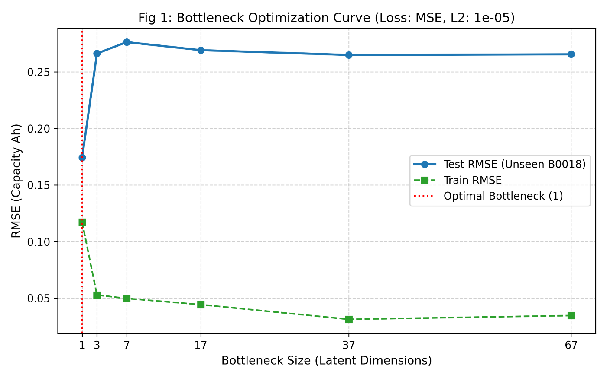
Figure 8: Bottleneck Optimization Curve.
Figure 8 shows a U-shape curve. A larger bottleneck decreases the train RMSE but increases the test RMSE on the unseen battery (B0018). This pattern indicates overfitting. The model memorizes the training domain but fails to generalize to the new domain.
To address the overfitting issue, I applied L2 regularization (weight decay) to penalize large weights in the network.
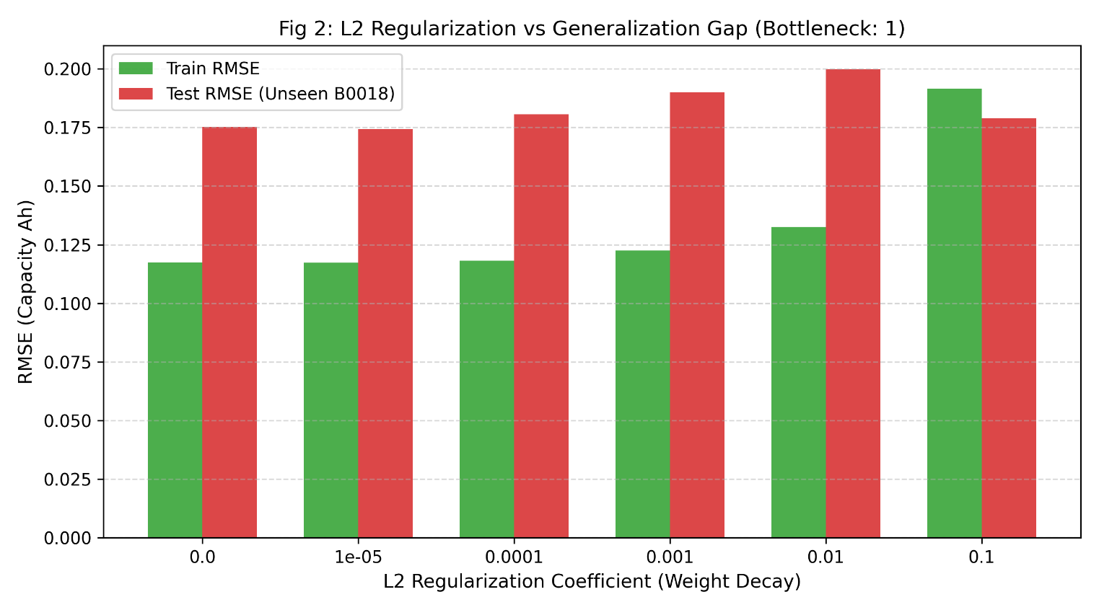
Figure 9: L2 Regularization vs. Generalization Gap (Bottleneck: 1).
Figure 9 displays the train and test RMSE across different L2 values. The gap between the train and test errors remains large in all cases. L2 regularization reduces model complexity, but it does not fix the domain shift problem. The fundamental issue is in the features, not the model weights.
Based on the numbers in the ablation study, the model with Bottleneck=1 achieved the lowest test RMSE. I plotted the prediction trajectory to inspect this specific result.
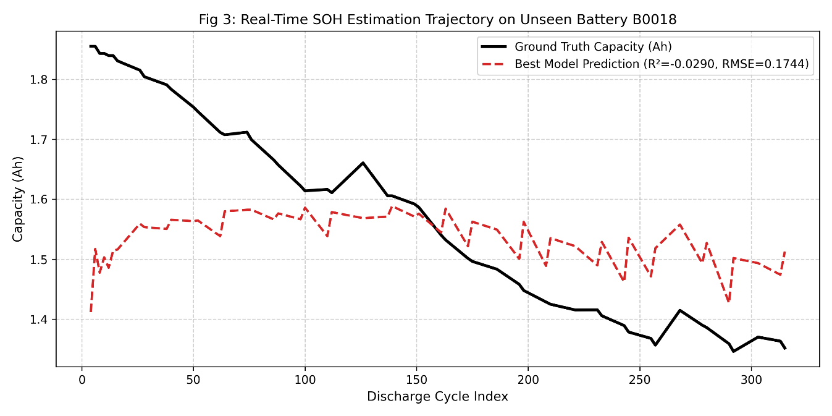
Figure 10: Real-Time SOH Estimation Trajectory on Unseen Battery B0018.
Figure 10 exposes a critical issue. The red dashed line (prediction) is a flat line. It sits near the mean value of the capacity. The model ignores the degradation trend of the raw data. It predicts the average value to minimize the mathematical error. This is known as the "mean prediction trap."
This result connects back to Section 4. The upstream Autoencoder provides distorted and flipped features to the downstream BPNN. The BPNN goes blind. To survive the unseen data, the model abandons trend prediction and outputs a flat average line.

Section 6: Next Steps for the Upcoming Progress
Based on the findings in the previous sections, I will address the data smoothing decision and outline the next steps.
Justification for Excluding the Moving Average In the data preparation phase, I decided to exclude the moving average technique for the SOH labels. The raw capacity data exhibits fluctuations over time. These fluctuations represent physical battery recovery during rest periods between cycles. A moving average filters out these variations. If we smooth the data, the model learns a synthetic trend. By keeping the raw fluctuations, the model can estimate the real-time battery health. This approach matches real-world electric vehicle conditions. The Battery Management System (BMS) must evaluate the current state, not an artificial smoothed state.
Next Steps Section 4 identified that the Autoencoder causes feature distortion on the unseen battery domain (Battery B0018). The Autoencoder extracts features, but these features change meaning in a new domain.
To address this issue, I will test alternative methods to see if they resist domain shift in our next iterations. The next steps include two new experimental pipelines:
- Raw EIS to BPNN: I will bypass the Autoencoder. I will input the 256 interpolation points from the PCHIP method straight into the BPNN. This will test if the neural network can learn from the raw physical shape.
- PCA to BPNN: I will use Principal Component Analysis to extract 17 features. I will input these PCA features into the BPNN. This will test if a standard linear transformation prevents the correlation flip issue found in the Autoencoder.
These upcoming experiments will compare domain shift resistance across different feature extraction methods. I will report the results in next update progress.

